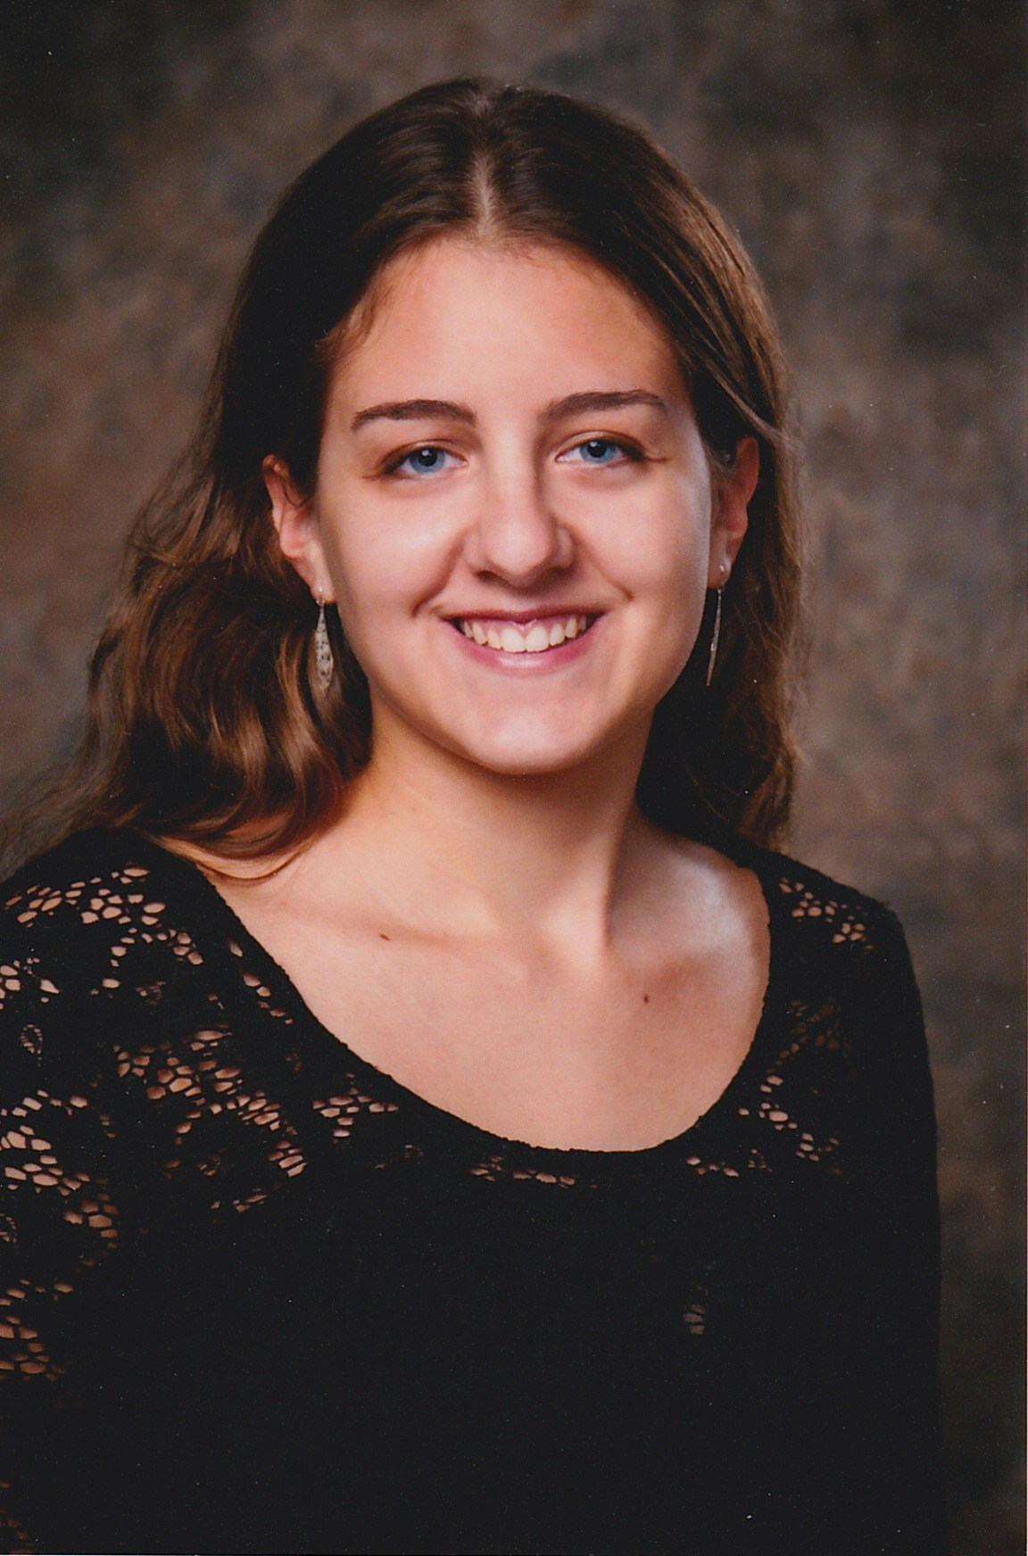 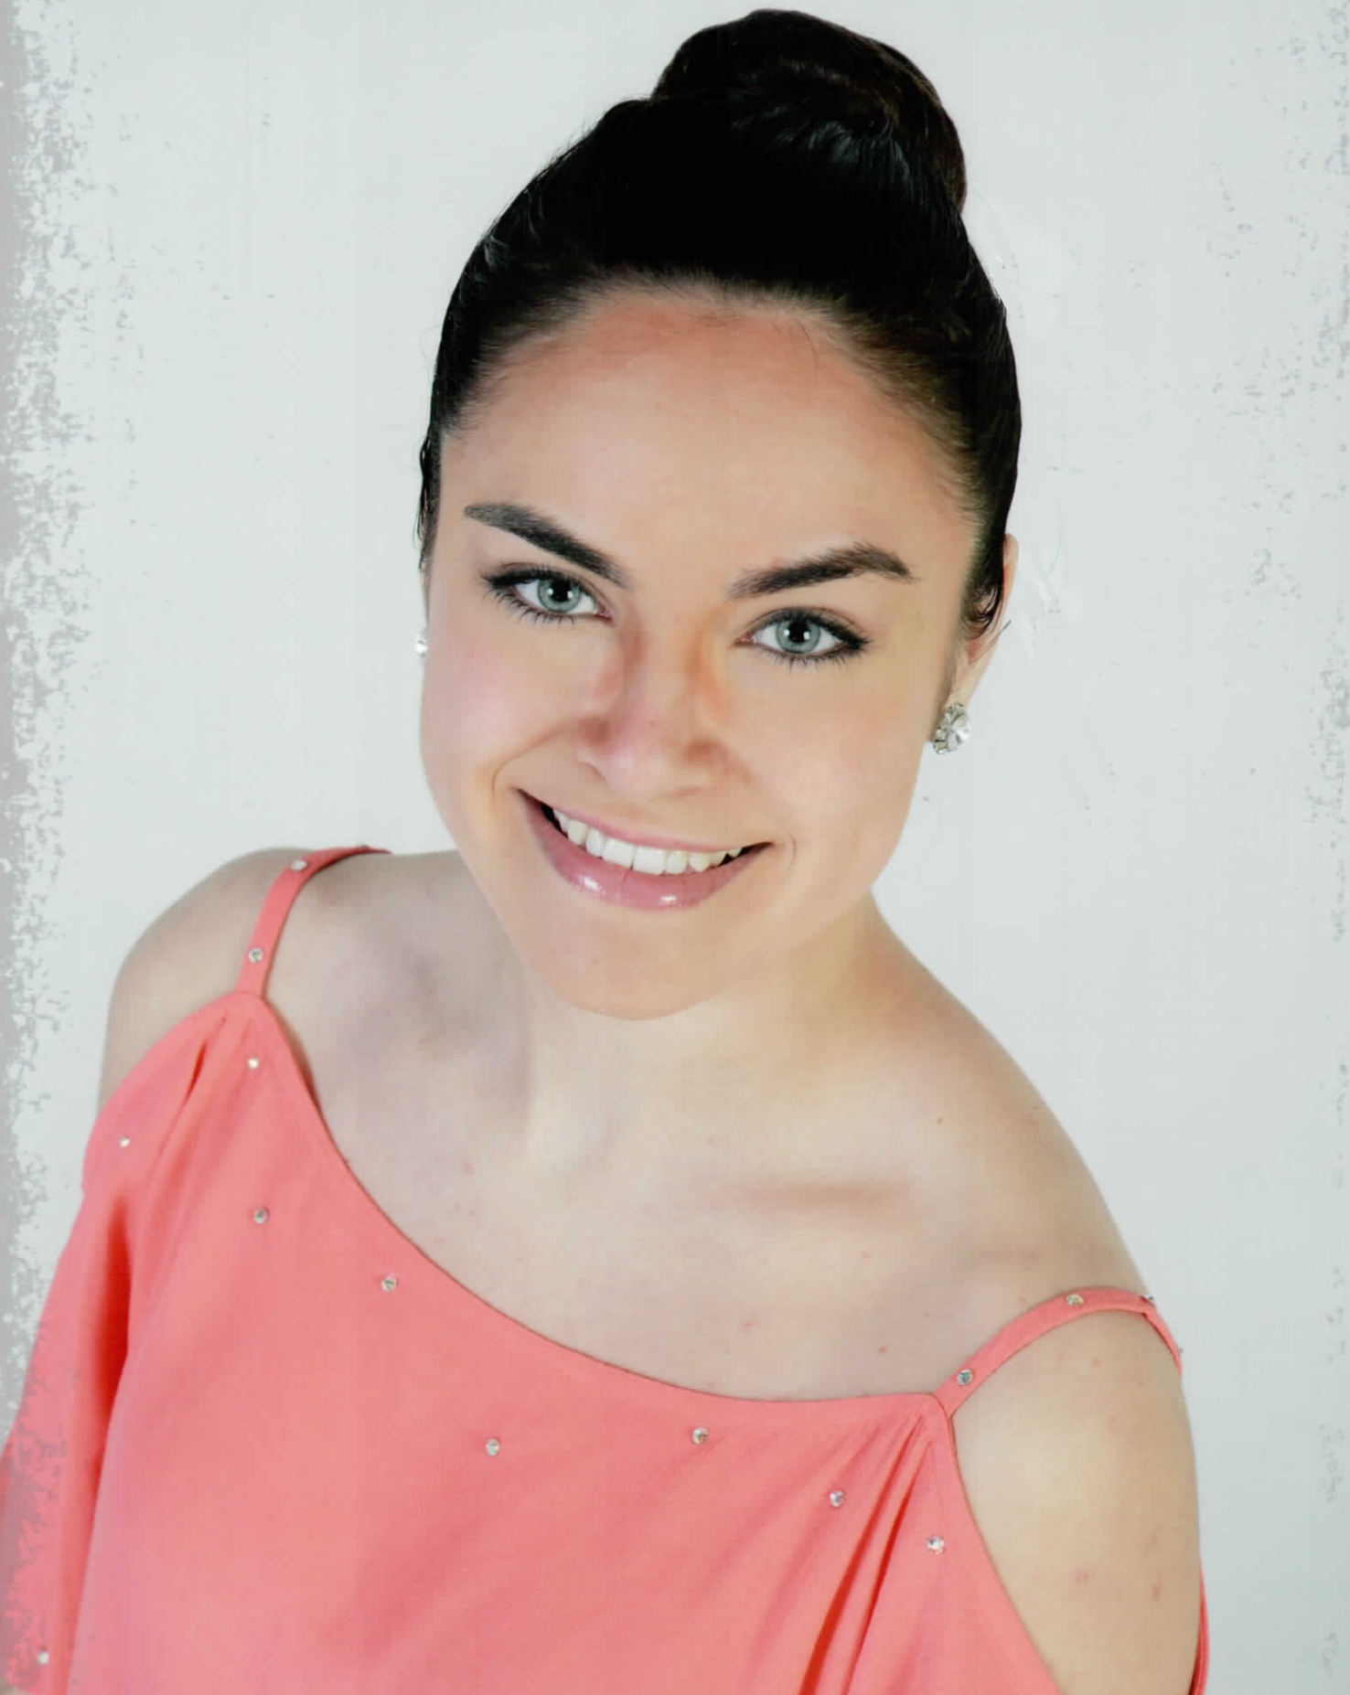 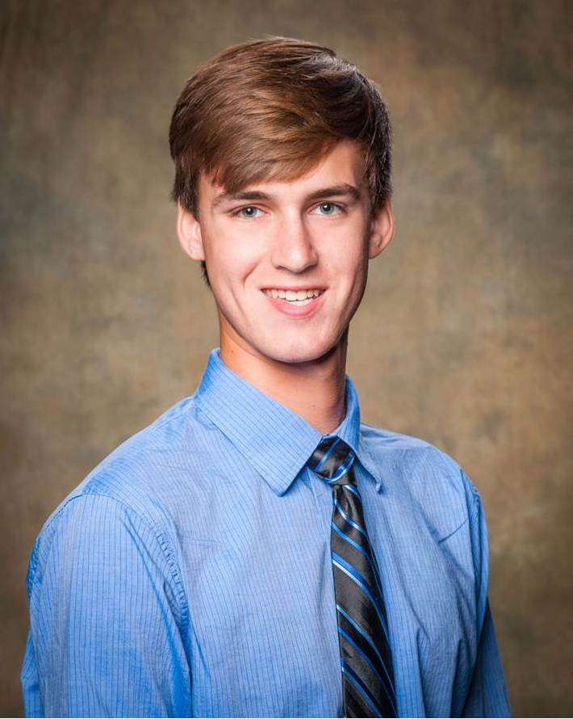
Claudia Buszta Alyssa Matz Nicholas Kavadas

For Immediate Release
May 28, 2015
Contact: Susan Dillman, Publicity Chairperson, 203-272-9055
Suburban Garden Club of Cheshire Announces 2015 Scholarships
The Suburban Garden Club of Cheshire is pleased to announce that the Club has awarded $500 scholarships to three graduating seniors at Cheshire High School.
Scholarships were awarded to Claudia Buszta, who will be majoring in Environmental Science at Colgate University and Alyssa Matz who plans to major in Biology and Environmental Science at the University of Connecticut.
In addition, the Suburban Garden Club Tripodina Growell Scholarship was awarded to Nicholas Kavadas, who will be majoring in Landscape Architecture at the University of Connecticut. The scholarship was named to acknowledge the tremendous contribution the Tripodina Family, owners of Growell Incorporated. in Cheshire, has made to the club by allowing the club to use greenhouse space to grow plants for their Annual Plant Sale. Proceeds from the plant sale fund the club’s scholarship program.

The Suburban Garden Club of Cheshire was founded in 1957 with the objective to encourage interest in all phases of gardening, promote better environmental practices and conservation of natural resources, increase knowledge in the artistic use of plant material in design and landscaping and assist in community beautification and civic involvement through member participation, contributions and charitable activities. For more information visit their website www.cheshiregardeners.org.

