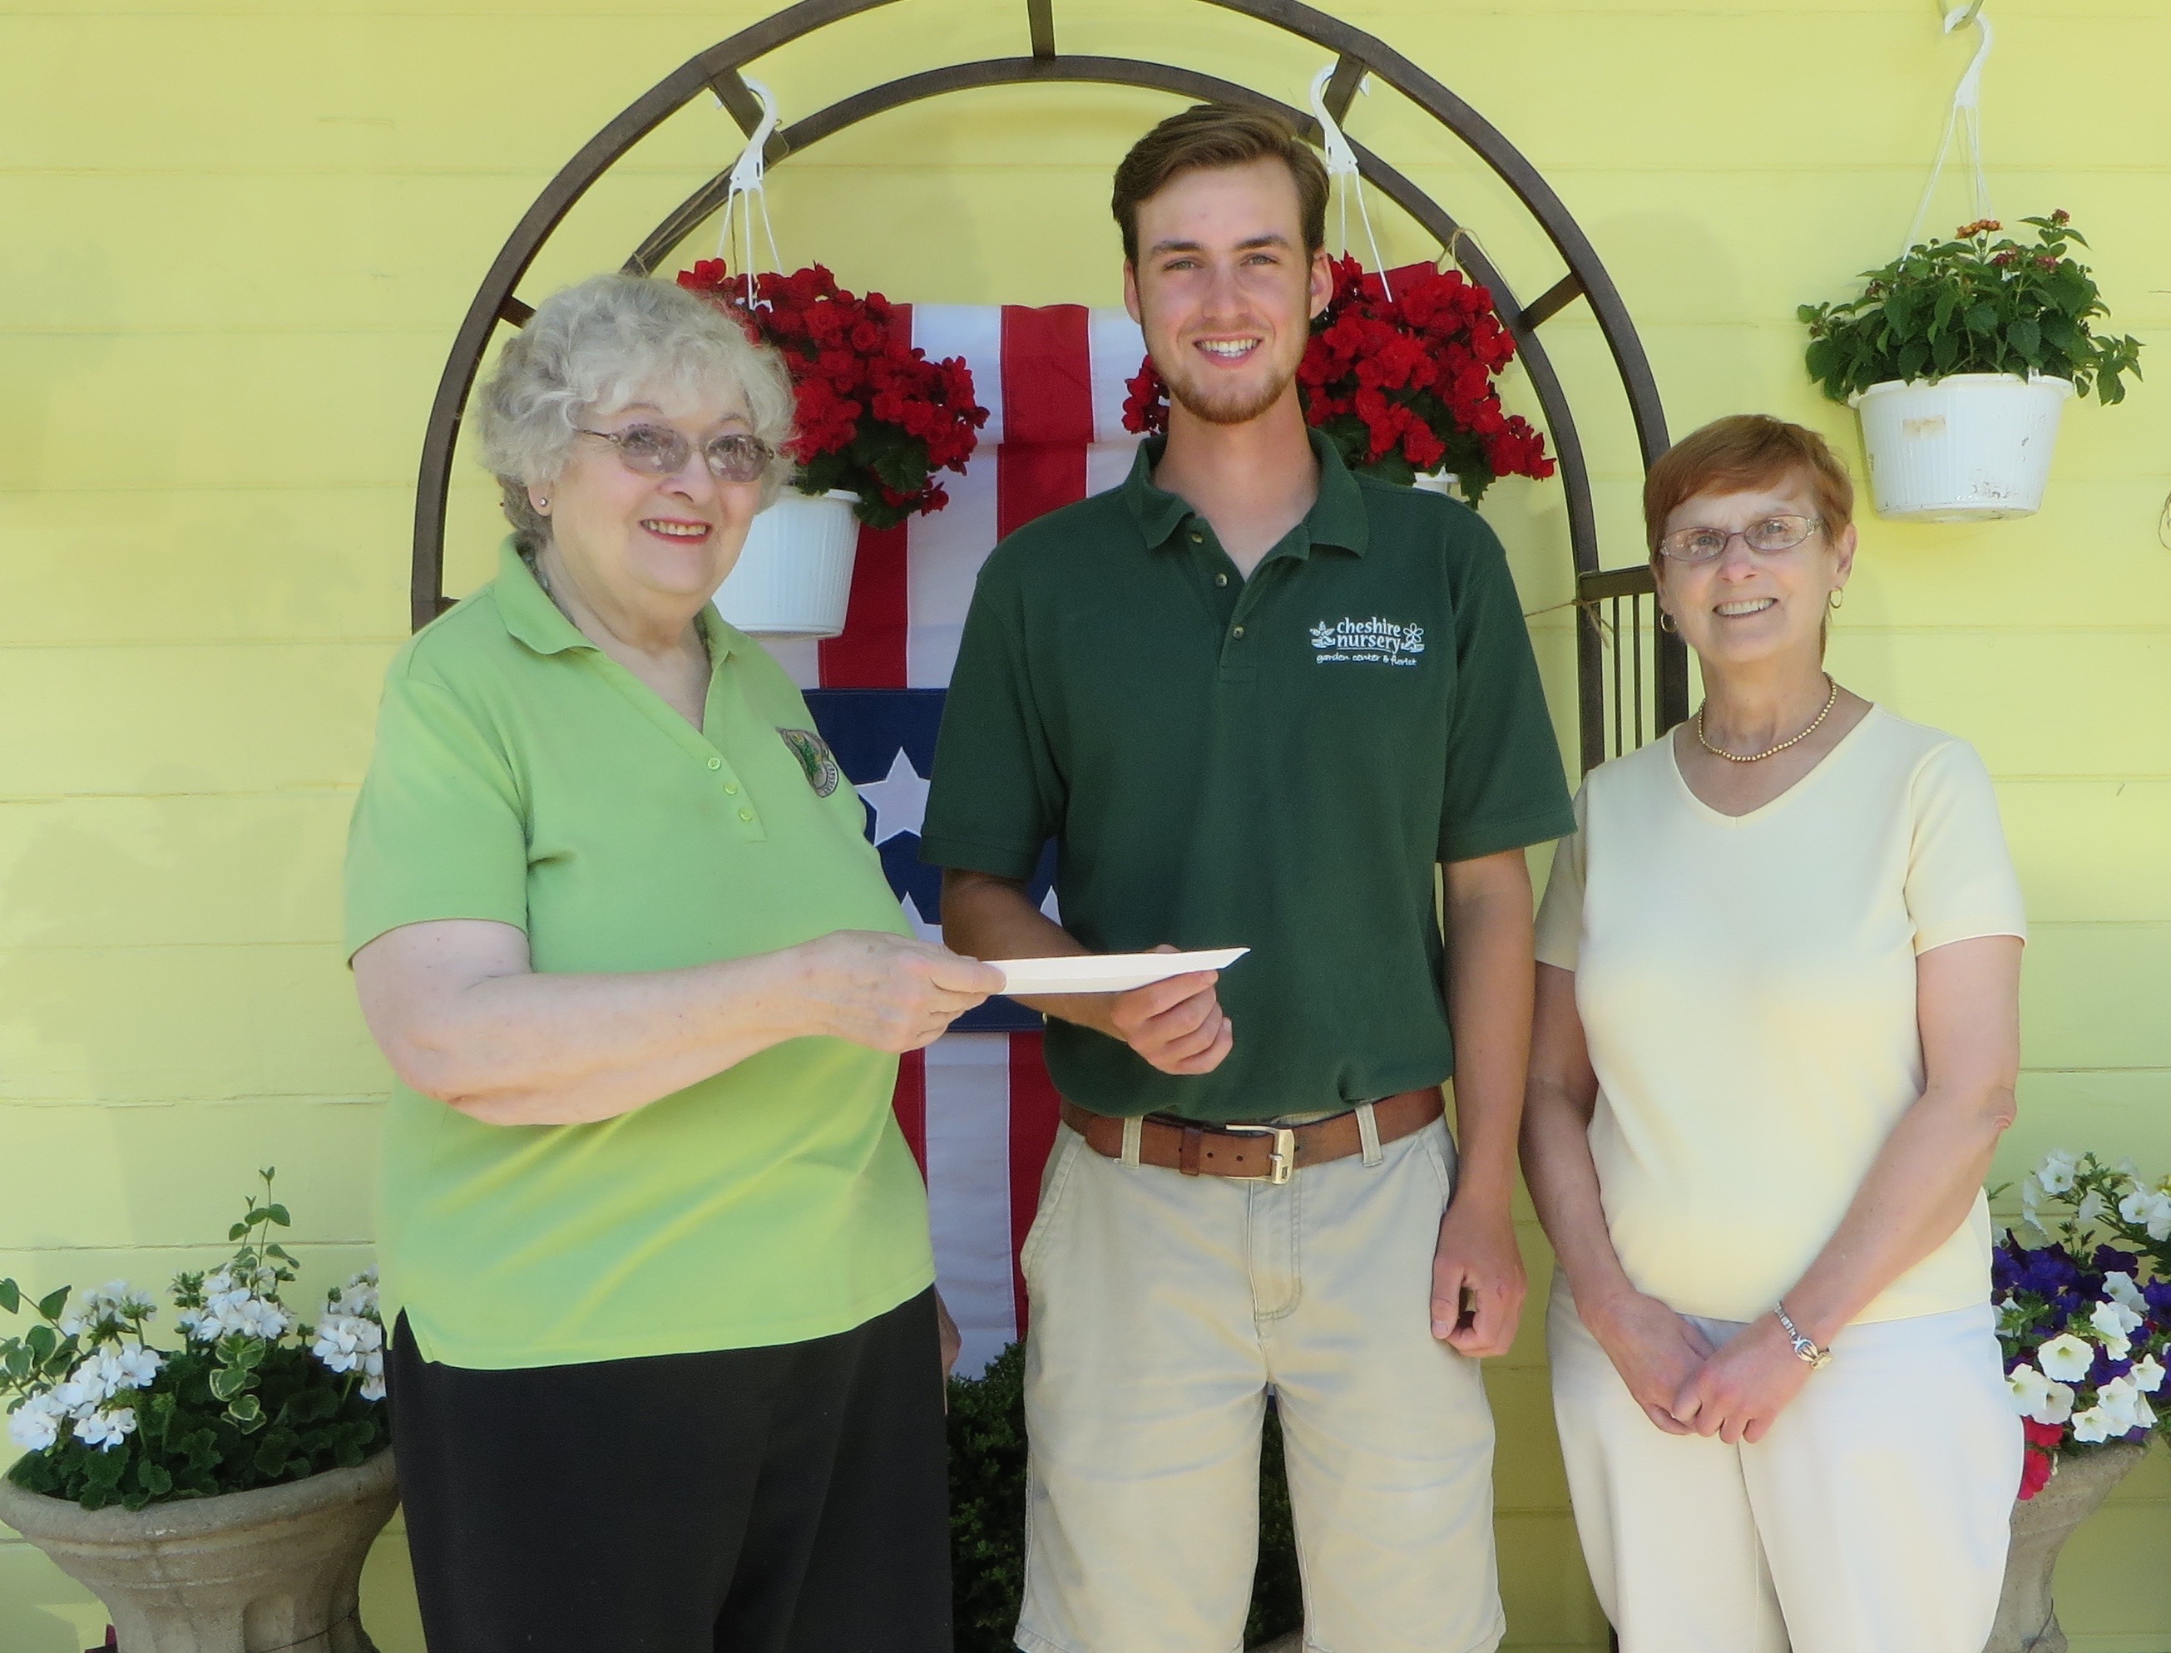

Mary Ellen Morgan, Nicholas Kavadas, Jr., Linda Broker

For Immediate Release

June 9, 2016

Suburban Garden Club of Cheshire Announces 2016 Tripodina GroWell Scholarship

The Suburban Garden Club of Cheshire is pleased to announce that the Club has awarded the Tripodina GroWell Scholarship in the amount of $1,000 to Nicholas Kavadas, Jr. Nicholas is majoring in landscape architecture. He currently attends the University of Connecticut, Waterbury campus and will be transferring to the Storrs campus. Mary Ellen Morgan, a chair of the Scholarship Committee and Linda Broker, President of the Suburban Garden Club made the presentation to Nicholas.

Nicholas has been employed at Cheshire Nursery Garden Center for the past two years, working close to full time when he is not in school. He also has his own small landscaping business. This is the second year that he has received the Tripodina GroWell scholarship. In 2015 he received this award as a graduating senior from Cheshire High School.

The Tripodina Growell Scholarship was named to acknowledge the tremendous contribution the Tripodina Family, owners of Growell Inc. in Cheshire, has made to the club by allowing the club to use greenhouse space to grow plants for their Annual Plant Sale. Proceeds from the plant sale fund the club’s scholarship program.

###

The Suburban Garden Club of Cheshire was founded in 1957 with the objective to encourage interest in all phases of gardening, promote better environmental practices and conservation of natural resources, increase knowledge in the artistic use of plant material in design and landscaping and assist in community beautification and civic involvement through member participation, contributions and charitable activities. For more information visit their website www.cheshiregardeners.org.

